

**Industrial Internship Report on**

**”AIR POLLUTION MONITORING SYSTEM”**

**Prepared by**

**[Nafeesh Amjad]**

|  |
| --- |
| *Executive Summary* |
| This report provides details of the Industrial Internship provided by upskill Campus and The IoT Academy in collaboration with Industrial Partner UniConverge Technologies Pvt Ltd (UCT).  This internship was focused on a project/problem statement provided by UCT. We had to finish the project including the report in 6 weeks’ time.  My project was AIR POLLUTION MONITORING SYSTEM  This internship gave me a very good opportunity to get exposure to Industrial problems and design/implement solution for that. It was an overall great experience to have this internship. |

**TABLE OF CONTENTS**

1 Preface 4

2 Introduction 4

2.1 About UniConverge Technologies Pvt Ltd 8

2.2 About upskill Campus 10

2.3 Objective 10

2.4 Reference 11

2.5 Glossary 11

3 Problem Statement 12

4 Existing and Proposed solution 13-15

5 Proposed Design/ Model 18

5.1 High Level Diagram (if applicable)

5.2 Low Level Diagram (if applicable)

5.3 Interfaces (if applicable)

6 Performance Test 20

6.1 Test Plan/ Test Cases 20

6.2 Test Procedure 23

6.3 Performance Outcome 24

7 My learnings 25

8 Future work scope 26

# Preface

Throughout these 6 weeks I have worked on our project which is "Air pollution monitoring system"

In first week we have worked on finding the relevant projects which is related to our carrer. We have worked on learning what actually IOT is, after that we have described our project and the working of the project, how it really works.

In second week we have worked on research and planning, sensor selection, hardware setup, also described why we are making this project after that we described the components which is to be used in this project like Arduino UNO, MQ135 GAS SENSOR etc.

In third week we have done work like working on the development of the software, data visualization and analysis, testing and collaboration, integration and deployment, maintenance and optimization.

In fourth week we have worked on coding in Arduino. Implementation of the project like assess the project plan, execute the plan, make changes as needed, analyze project data, gather feedback.

In fifth week we have worked on the flaws, taking feedback form people

**About need of relevant Internship in career development.**

Relevant internships play a crucial role in career development for several reasons:

Skill development: Internships provide opportunities to acquire practical, hands-on skills that are relevant to the chosen field. Unlike theoretical learning, internships allow individuals to apply their knowledge in real-world scenarios, enhancing their problem-solving abilities and technical expertise.In summary, relevant internships provide a unique opportunity for individuals to bridge the gap between academia and the professional world. They offer practical experience, exposure, and networking opportunities that are instrumental in shaping a successful and fulfilling career path.

**Brief about Your project/problem statement.**

The Air Pollution Monitoring System is a project designed to monitor and assess air quality in a specific area. It uses a network of sensors to measure pollutants like PM2.5, PM10, NO2, SO2, O3, CO, and VOCs in real-time. Data is processed and presented through visualizations, alerts, and notifications when pollutant levels exceed limits. A user-friendly web or mobile app provides access to real-time and historical data, promoting public awareness and informed decision-making. The system aids in environmental impact assessment and empowers authorities to implement effective measures for combating air pollution and protecting public health and the environment.

Opportunity given by USC/UCT.

Thank you for giving such an wonderful opportunity which is related to my career

**Your Learnings and overall experience.**

Overall experience and learning at UPSKILL CAMPUS was really great as it helped me to boost my career. The mentors here are very helpful as they have helped us at every moment whenever we were facing issues so overall experience and learning was very good.

Thank to all Upskill campus, Apurv, who have helped me directly or indirectly.

Your message to your juniors and peers.

I will recommend my junior and peers to get your internship at UPSKILL CAMPUS as it provides the best mentors who will you throughout your project journey.

# Introduction

## About UniConverge Technologies Pvt Ltd

A company established in 2013 and working in Digital Transformation domain and providing Industrial solutions with prime focus on sustainability and RoI.

For developing its products and solutions it is leveraging various**Cutting Edge Technologies e.g. Internet of Things (IoT), Cyber Security, Cloud computing (AWS, Azure), Machine Learning, Communication Technologies (4G/5G/LoRaWAN), Java Full Stack, Python, Front end**etc.



1. UCT IoT Platform ()

**UCT Insight** is an IOT platform designed for quick deployment of IOT applications on the same time providing valuable “insight” for your process/business. It has been built in Java for backend and ReactJS for Front end. It has support for MySQL and various NoSql Databases.

* It enables device connectivity via industry standard IoT protocols - MQTT, CoAP, HTTP, Modbus TCP, OPC UA
* It supports both cloud and on-premises deployments.

It has features to  
• Build Your own dashboard  
• Analytics and Reporting  
• Alert and Notification  
• Integration with third party application(Power BI, SAP, ERP)  
• Rule Engine

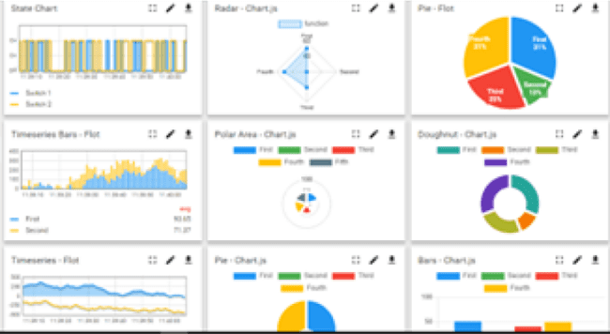 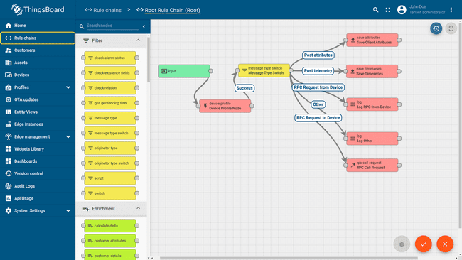

1. **Smart Factory Platform (****)**

Factory watch is a platform for smart factory needs.

It provides Users/ Factory

* with a scalable solution for their Production and asset monitoring
* OEE and predictive maintenance solution scaling up to digital twin for your assets.
* to unleased the true potential of the data that their machines are generating and helps to identify the KPIs and also improve them.
* A modular architecture that allows users to choose the service that they what to start and then can scale to more complex solutions as per their demands.

Its unique SaaS model helps users to save time, cost and money.

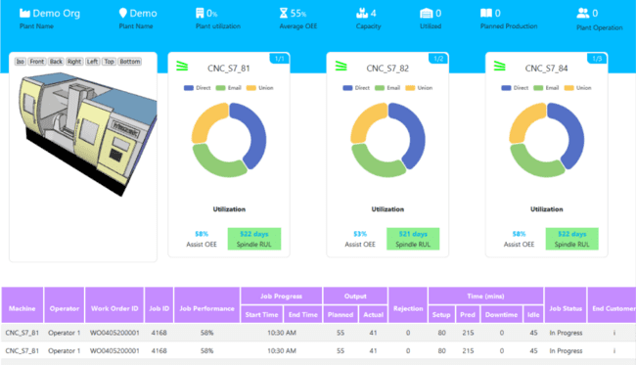 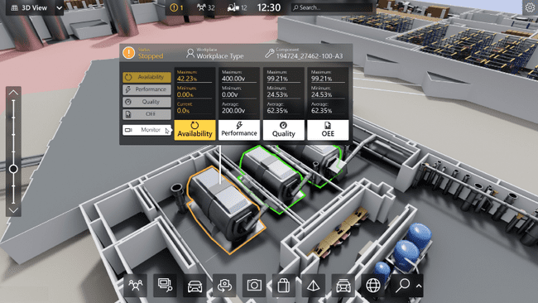

1. 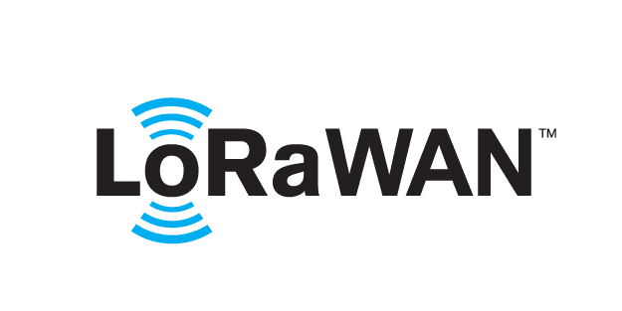 based Solution

UCT is one of the early adopters of LoRAWAN teschnology and providing solution in Agritech, Smart cities, Industrial Monitoring, Smart Street Light, Smart Water/ Gas/ Electricity metering solutions etc.

1. Predictive Maintenance

UCT is providing Industrial Machine health monitoring and Predictive maintenance solution leveraging Embedded system, Industrial IoT and Machine Learning Technologies by finding Remaining useful life time of various Machines used in production process.

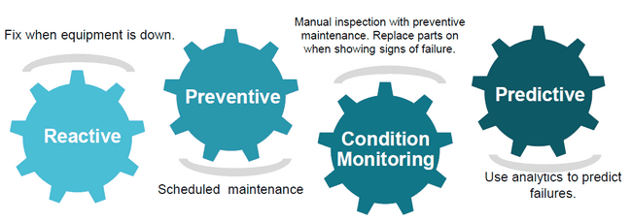

## About upskill Campus (USC)

upskill Campus along with The IoT Academy and in association with Uniconverge technologies has facilitated the smooth execution of the complete internship process.

USC is a career development platform that delivers **personalized executive coaching** in a more affordable, scalable and measurable way.

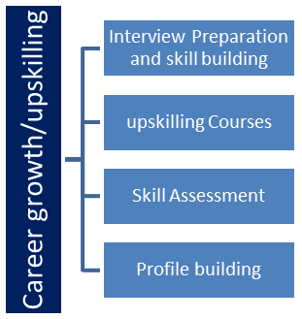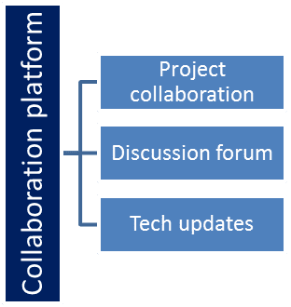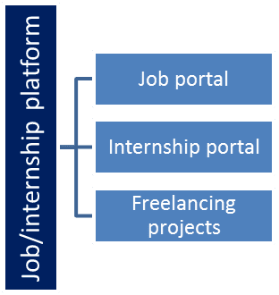

## The IoT Academy

The IoT academy is EdTech Division of UCT that is running long executive certification programs in collaboration with EICT Academy, IITK, IITR and IITG in multiple domains.

## Objectives of this Internship program

The objective for this internship program was to

 ☛ get practical experience of working in the industry.

 ☛ to solve real world problems.

 ☛ to have improved job prospects.

 ☛ to have Improved understanding of our field and its applications.

 ☛ to have Personal growth like better communication and problem solving.

## Reference

[1] RiteekaNayak, Malaya RanjanPanigrahy, Vivek Kumar Rai and T Appa Rao: IOT based air pollution monitoring system Vol-3, Issue-4, 2017

[2] NavreetinderKaur,Rita Mahajan and Deepak Bagai: Air Quality Monitoring System based on Arduino Microcontroller Vol. 5, Issue 6, June 2016

[3] PalaghatYaswanth Sai: An IoT Based Automated Noise and Air Pollution Monitoring System Vol. 6, Issue 3, March 2017

## Glossary

|  |  |
| --- | --- |
| Terms | Acronym |
|  |  |
|  |  |
|  |  |
|  |  |
|  |  |

# Problem Statement

The problem statement of the project "AIR POLLUTION MONITORING SYSTEM" is to develop a comprehensive and efficient system that can continuously monitor and assess the quality of air in a specific location or across multiple locations. The main objective is to accurately measure various air pollutants, such as particulate matter (PM2.5 and PM10), ozone (O3), nitrogen dioxide (NO2), sulfur dioxide (SO2), carbon monoxide (CO), volatile organic compounds (VOCs), and other harmful gases.

The system should be capable of collecting real-time data from various sensors strategically placed in the target area. These sensors should be able to monitor the air quality parameters continuously and provide accurate and reliable measurements.

The project aims to address the following aspects:

* Air Quality Monitoring: Develop a network of sensors capable of measuring various air pollutants accurately and providing real-time data updates.
* Data Collection and Transmission: Implement a data collection mechanism that efficiently gathers data from the sensors and transmits it to a central processing unit or cloud-based server.
* Data Analysis and Interpretation: Develop algorithms and data processing techniques to analyze the collected data, interpret the air quality levels, and assess potential health risks for the population.
* Data Visualization and Reporting: Create a user-friendly interface to visualize the air quality data, present it in a comprehensible manner to users, and generate regular reports or alerts when pollution levels exceed safety thresholds.
* Accessibility and Scalability: Design the system to be accessible to various stakeholders, including local authorities, environmental agencies, and the general public. The system should also be scalable, allowing for expansion to cover larger geographical areas if required.
* Maintenance and Calibration: Establish a maintenance plan for the sensors and ensure their periodic calibration to maintain data accuracy and reliability.

Overall, the goal of the "AIR POLLUTION MONITORING SYSTEM" project is to provide valuable insights into the air quality of the monitored area, raise awareness about pollution levels, and aid in making informed decisions to mitigate the adverse effects of air pollution on public health and the environment.

# Existing and Proposed solution

Provide summary of existing solutions provided by others, what are their limitations?

The existing solution for an air pollution monitoring system typically involves a network of sensors and data collection devices deployed in various locations to measure air quality parameters. Here is a summary of the typical solution and its limitations:

* Limited Coverage: The current air pollution monitoring systems may not have sensors in all areas, leading to gaps in data representation. Some remote or less populated regions might not have sufficient coverage, leaving them unaware of local air quality conditions.
* Sensor Accuracy and Maintenance: The accuracy and calibration of sensors can vary, leading to potential inconsistencies in the data. Regular maintenance is required to ensure proper functioning and reliable measurements.
* Cost Constraints: Expanding the sensor network and maintaining it can be expensive, especially for regions with limited resources or budgets. This can hinder the establishment of comprehensive monitoring systems
* Inadequate Sensor Types: While the existing systems measure common pollutants, they might not cover all relevant air quality parameters. For instance, data on volatile organic compounds (VOCs) and specific aerosols might be missing.
* Data Interpretation: While the data is valuable, its meaningful interpretation and analysis are necessary for making informed decisions. Lack of public awareness and understanding can limit the impact of the data.
* Response Time: Data processing and transmission may have some latency, which could affect real-time decision-making during air pollution incidents

**What is your proposed solution?**

Our proposed air pollution monitoring system involves deploying a network of sensors to measure various pollutants in the air, such as PM2.5, PM10, NO2, SO2, O3, CO, and VOCs. The collected data is transmitted in real-time to a centralized database through a communication infrastructure like Wi-Fi or cellular networks. Algorithms and machine learning are used to analyze the data and identify pollution patterns. The results are visualized in a user-friendly dashboard, which also includes historical trends and alerts when pollution levels exceed certain thresholds. The system integrates with GIS to map pollution hotspots and engages the community through open data access and educational campaigns. Collaboration with research institutions and governmental agencies is encouraged and regular maintenance and calibration of sensors are ensured for accuracy and reliability. The system is designed for scalability and future expansion. Overall, the solution aims to raise awareness, enable informed decision-making, and contribute to pollution control efforts.

**What value addition are you planning?**

Various value-additions that we have planned for the project "Air Pollution Monitoring System" to enhance its overall value and effectiveness:

* Real-time Data Visualization: Implement a user-friendly dashboard with interactive charts and maps for displaying real-time air pollution data.
* Mobile Application: Develop a mobile app to provide users with on-the-go access to air quality information and personalized alerts.
* Predictive Analytics: Utilize machine learning to predict future air pollution levels based on historical data and relevant factors.
* Data Correlation: Integrate data from different sources to identify correlations and pinpoint pollution sources.
* Air Quality Index (AQI) Forecasting: Create a forecasting model for short-term and long-term AQI predictions.
* Public Awareness Campaigns: Conduct educational campaigns to raise awareness about air pollution and promote sustainable practices.
* Community Engagement: Encourage community participation by allowing users to report incidents and share observations.
* IoT Sensor Integration: Expand the monitoring network with IoT-based air quality sensors in various locations.

## Code submission (Github link)

## Report submission (Github link) : first make placeholder, copy the link.

# Proposed Design/ Model

We have designed an Air Pollution Monitoring System involves multiple components that work together to measure and analyze air quality data.

**Sensor Nodes:**

Deploy sensor nodes throughout the target area to measure various air pollutants such as particulate matter (PM2.5, PM10), carbon monoxide (CO), sulfur dioxide (SO2), nitrogen dioxide (NO2), ozone (O3), etc. These sensor nodes should be equipped with appropriate sensors to capture the required data accurately.

**Data Collection:**

Sensor nodes gather real-time air quality data and send it to a centralized database or a cloud-based platform for storage and further processing.

Ensure that the data transmission is secure and reliable to prevent data loss or tampering during transit.

**Data Processing:**

Data received from various sensor nodes is processed to handle any inconsistencies, calibration errors, or outliers.

Implement algorithms for data validation, filtering, and smoothing to improve data accuracy and remove noise.

**Data Visualization:**

Develop a user-friendly interface to visualize the processed data. This can be a web application, mobile app, or a dedicated dashboard.

Display real-time and historical data in the form of charts, graphs, maps, or other appropriate visualizations.

**Alerting Mechanism:**

Set threshold levels for each pollutant to determine acceptable air quality limits.

Implement an alerting mechanism that triggers notifications (e.g., email, SMS) to relevant authorities or the public when pollution levels exceed the predefined thresholds.

**Historical Data Storage:**

Store historical air quality data for analysis, reporting, and trend analysis.

Use databases or cloud storage solutions capable of handling large datasets efficiently.

**Data Analysis and Reporting:**

Conduct data analysis to identify trends, patterns, and potential sources of pollution.

Generate periodic reports and insights that can be used for decision-making and policy formulation.

**Public Access:**

If applicable, provide public access to the air quality data through APIs or publicly available web pages.

This can empower citizens to make informed decisions and raise awareness about air quality issues.

**Maintenance and Calibration:**

Regularly maintain and calibrate the sensor nodes to ensure their accuracy and reliability.

Implement mechanisms to detect and report any malfunctioning sensors or nodes.

**Integration with Environmental Agencies:**

Collaborate with relevant environmental agencies to share the collected data and contribute to broader air quality monitoring efforts.

**Continuous Improvement:**

Gather feedback from users and stakeholders to identify areas for improvement.

Continuously update and enhance the system based on feedback and technological advancements

## High Level Diagram (if applicable)

**Figure 1: HIGH LEVEL DIAGRAM OF THE SYSTEM**

## Low Level Diagram (if applicable)

## Interfaces (if applicable)

Update with Block Diagrams, Data flow, protocols, FLOW Charts, State Machines, Memory Buffer Management.

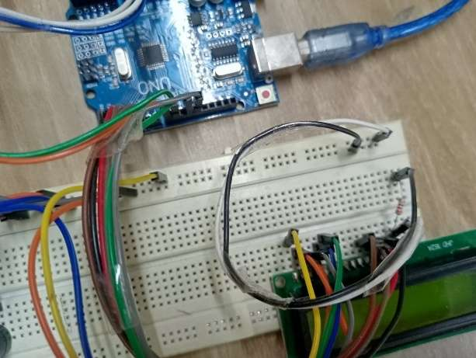           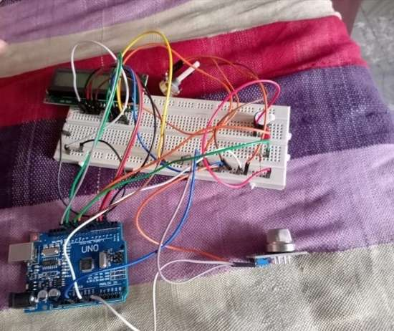

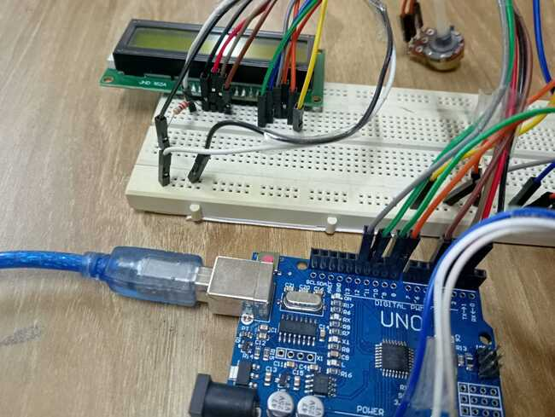

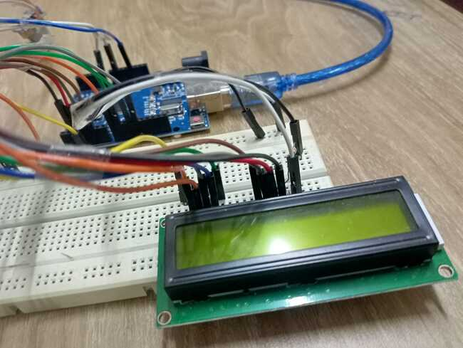

# Performance Test

This is very important part and defines why this work is meant of Real industries, instead of being just academic project.

Here we need to first find the constraints.

How those constraints were taken care in your design?

The specific constraints considered will depend on the project's scope, objectives, budget, and intended application. Engineers and stakeholders involved in the project typically conduct thorough research and analysis to determine the most appropriate constraints for the air pollution monitoring system.

What were test results around those constraints?

It's important to note that test results and evaluations should be documented thoroughly, and any discrepancies or issues discovered during testing should be addressed and rectified accordingly. Additionally, results may be compared against project objectives and requirements to determine if the system meets the specified constraints

Constraints can be e.g. memory, MIPS (speed, operations per second), accuracy, durability, power consumption etc.

In case you could not test them, but still you should mention how identified constraints can impact your design, and what are recommendations to handle them.

## Test Plan/ Test Cases

Creating a test plan and test cases for an air pollution monitoring system involves verifying its functionality, accuracy, and reliability.

## Test Procedure

**Objective and Scope**

1. Clearly define the objectives of the testing and the scope of the system being tested. Determine what aspects of the system need evaluation and what kind of scenarios the system should be able to handle.

**Test Environment**

1. Set up the testing environment to closely resemble real-world conditions in which the air pollution monitoring system will be deployed. This may involve selecting specific locations with varying pollution levels, weather conditions, and geographic features.

**Functional Testing**

1. Verify that the system functions as intended. This involves testing individual components and their interactions to ensure the system performs the expected operations, such as data collection, data processing, and data presentation.

**Data Accuracy**

1. Evaluate the accuracy of the collected data by comparing the system's readings with reference measurements obtained from trusted sources or calibrated instruments.

**Data Reliability**

1. Assess the reliability of the system by conducting long-term tests to observe its performance over extended periods. Ensure that the system consistently provides reliable data without significant downtime or malfunctions.

**Threshold and Alert Testing**

1. Set threshold levels for different pollutants (e.g., particulate matter, ozone, nitrogen dioxide) and test the system's ability to trigger appropriate alerts when pollution levels exceed these thresholds.

**Data Transmission**

1. Evaluate the efficiency and reliability of data transmission from the monitoring devices to the central database or server. Test the system's ability to handle a large volume of data in real-time.

**Power Management (if applicable)**

1. If the system operates on batteries or solar power, test its power management features to ensure efficient use of energy and optimal battery life.

**User Interface Testing**

1. Verify that the user interface (UI) is intuitive, user-friendly, and provides relevant information to users. Test different scenarios to assess how well users can interact with the system.

**Environmental Factors**

1. Assess how the system performs under various environmental conditions, such as extreme temperatures, humidity, and exposure to dust or water.

**Interoperability**

1. If the system integrates with other devices or platforms, test its interoperability with those components to ensure seamless data exchange.

**Security Testing**

1. Conduct security testing to identify and address potential vulnerabilities, especially if the system relies on data communication and storage.

**Documentation Review**

1. Review all system documentation, including user manuals and technical guides, to ensure they accurately represent the system's functionality and operation.

**Performance Evaluation**

1. Measure and evaluate the system's overall performance based on predefined criteria and performance metrics.

**End-User Testing**

1. Finally, involve end-users or stakeholders to participate in usability testing and gather feedback on their experience using the air pollution monitoring system

## Performance Outcome

To assess the performance outcome, compare the actual results against the predefined targets and objectives of the project. If the system meets or exceeds the set goals and improves the understanding and management of air pollution, it can be considered successful.

# My learnings

Overall, my experience with the air pollution monitoring system project likely enriched my skills knowledge and skills in environmental science, data analysis, technology, and public health, while also fostering a greater sense of environmental responsibility and the need for sustainable practices.

# Future work scope

We have put some ideas that could not work due to time limitation but can be taken in future.

Here are some potential future directions for an air pollution monitoring system project:

**Integration of Advanced Sensors:** Explore the incorporation of advanced air quality sensors that can detect a broader range of pollutants with higher precision. This might involve using sensor technologies such as nanotechnology-based sensors or laser-based instruments.

**Real-Time Data and Reporting:** Enhance the system to provide real-time data and reporting. This could include setting up continuous data streaming, cloud-based storage, and developing a user-friendly interface accessible through mobile applications or web platforms.

**AI and Machine Learning Integration:** Integrate AI and machine learning algorithms to analyze the collected data more effectively. This could involve pattern recognition for identifying pollution sources, predictive modeling for forecasting air quality changes, and anomaly detection for spotting unusual pollution events.

**Spatial Analysis and Mapping:** Develop GIS (Geographic Information System) capabilities to visualize air pollution data spatially. This would enable authorities to identify pollution hotspots and plan targeted interventions.

**Public Awareness and Engagement:** Create features that allow users to receive personalized air quality alerts and recommendations to reduce exposure during periods of high pollution. Additionally, consider incorporating educational components to raise public awareness about air pollution and its health effects.

**Collaboration with Health Services:** Establish connections with healthcare providers to correlate air quality data with public health records. This could help in understanding the impact of air pollution on specific health conditions.

**Particulate Matter Analysis:** Focus on improving the measurement and analysis of particulate matter (PM) as it is a significant component of air pollution and has severe health implications.

**Mobile Monitoring:** Develop portable and wearable air quality monitoring devices that individuals can carry with them to measure their personal exposure levels. This would provide more granular data and empower individuals to make informed decisions.

**Sensor Calibration and Maintenance:** Implement automatic calibration routines and regular maintenance checks to ensure the accuracy and reliability of the sensor data.

**Data Sharing and Collaboration:** Explore opportunities for data sharing and collaboration with other air quality monitoring networks and research institutions. This could contribute to a more comprehensive understanding of air pollution on a regional or global scale

**Integration with Urban Planning:** Work with urban planners and policymakers to integrate air pollution data into city planning and development strategies to create more sustainable and pollution-conscious urban environments.